Name: Zixiao Wang, Yue Zhang

NetID: zw579, yz2455

Lab1 Week2 Report

1. First, FIFO is named-PIPE that exists in the filesystem just like a regular file while PIPE doesn’t exist in the filesystem.

Second, PIPE is only used for communication between related processes with common ancestors while FIFO can be used for any unrelated processes, which is what we cannot do with PIPE.

1. The source of our confusion comes from not familiar with how fifo works. From this guide, we know that mplayer could read commands from a fifo file by the phrase: mplayer -input file=/home/pi/video_fifo bigbuckbunny_videos.mp4, each time we write command to the fifo file, such as “echo “pause” > /home/pi/test_fifo”, mplayer will read that command. But we are not sure of the details how fifo send command to mplayer.
2. Pin#3 SDA: Data Line of I2C

Pin#5 SCL: Clock Line of I2c

Pin#19 MOSI: Master Output Slave Input of SPI

Pin#21 MISO: Master Input Slave Output of SPI

Pin#18 RT_INT

Pin#22 TFT_DC_3V: TFT 3.3V Power Supply

Pin#24 TFT_CS_3V: TFT Chip Select

Pin#23 SCLK: Serial Clock

1. All possible GPIO pins may be used(maximum set):

GPIO2, GPIO3, GPIO4, GPIO5, GPIO6, GPIO7, GPIO8, GPIO9, GPIO10, GPIO11, GPIO12, GPIO13, GPIO14, GPIO15, GPIO16, GPIO17, GPIO18, GPIO19, GPIO20, GPIO21, GPIO22, GPIO23, GPIO24, GPIO25, GPIO26, GPIO27

Minimun set:

GPIO5, GPIO6, GPIO13, GPIO19, GPIO26, GPIO12, GPIO16, GPIO20, GPIO21

1. The shell script should firstly call video_control.py and run it in background; then call mplayer to play video on foreground. Thus, mplayer can receive command sent from video_control through video_fifo and return to command window when command “quit” is detected.
2. When we connect Pi to the Internet via Ethernet or wifi, accurate time and date will update automatically from the global ntp(network time protocol) server according to our chosen timezone and country.

If we want to keep accurate time and date when we cut off the internet or power off the Pi, we need extra Real Time Clock module.

1. Linux is a multi-user, multi-process system, therefore, it allows two or more users modify the configuration at the same time. There could be situations when one user set the GPIO as input mode and another set it as output mode. In such case when button is pressed and there’s no resistor between ground and output GPIO, which means power and ground is shorted, GPIO will be damaged because of large current. Therefore, it’s necessary to put a current-limiting resistor, R2 in this case. Because GPIO output voltage is 3.3v, a 1K ohm resistor could limit current to 3.3mA, which is acceptable.
2. Pygame is a python wrapper and surface is like a piece of paper that could be

created with this pygame wrapper by “pygame.display.set_mode()”. Whatever we do to the surface, results will display on the screen. Rect is an object in pygame used to store and manipulate rectangular areas, it can be created from objects that are already a rect or directly created from a combination of left, top, width and height values. Besides, we could use pygame.draw.rect() to draw a rectangular.

Use surface and rect to animate image: firstly we set the size and background color of surface, load an image and use image.get_rect() to get the location information of image, change the display location and angle of image, such as changing rect.x or rect.y in the loop. By changing coordinate or other characteristic of the image, we could realize animating an image.

Take the following program as an example:

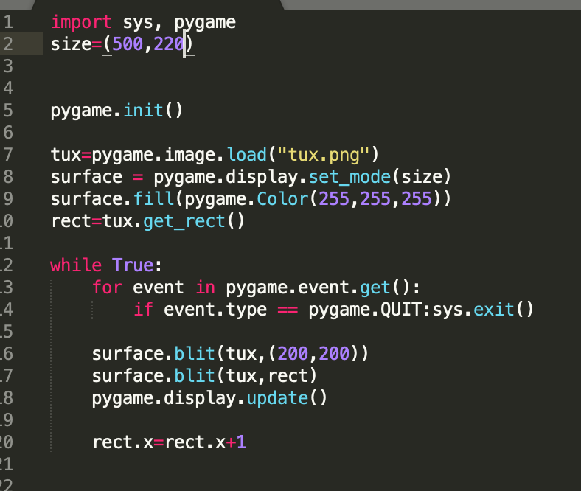

Running this program, the tux could moving rightward on the surface.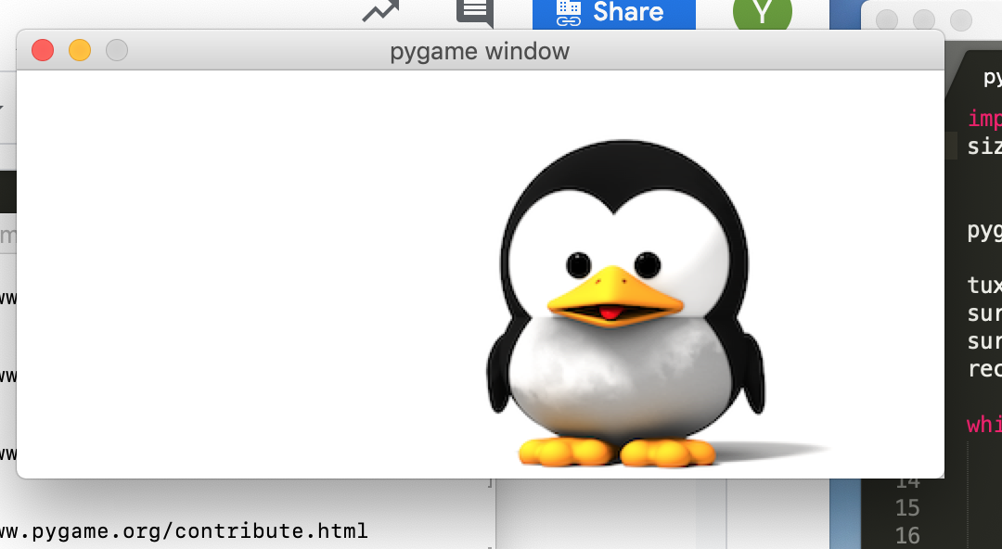

Establish a touchscreen button by detecting MOUSEBUTTONDOWN and MOUSEBUTTONUP events, program is as follows:

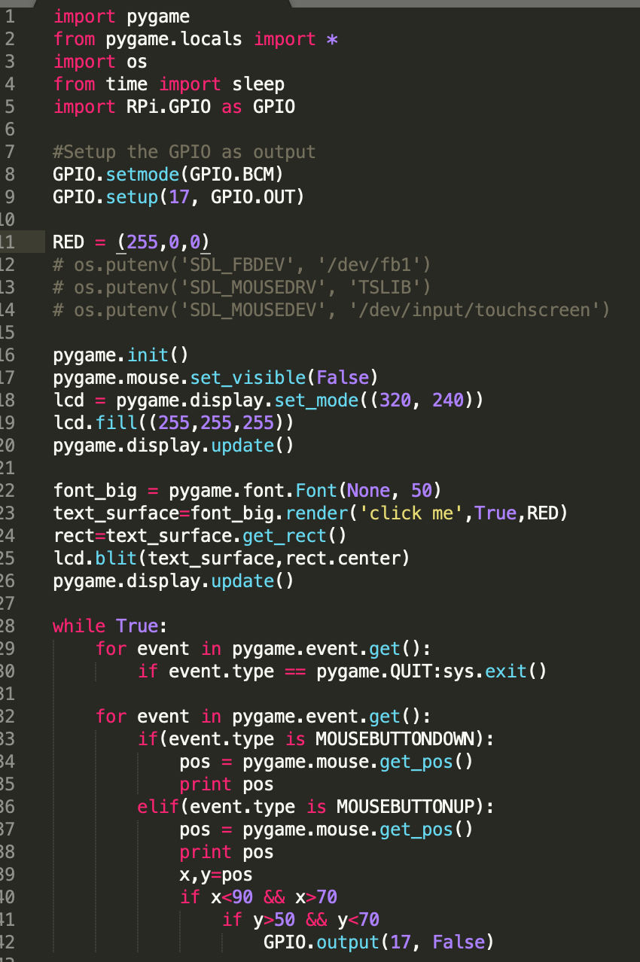

I tried this result on laptop by clicking with mouse:

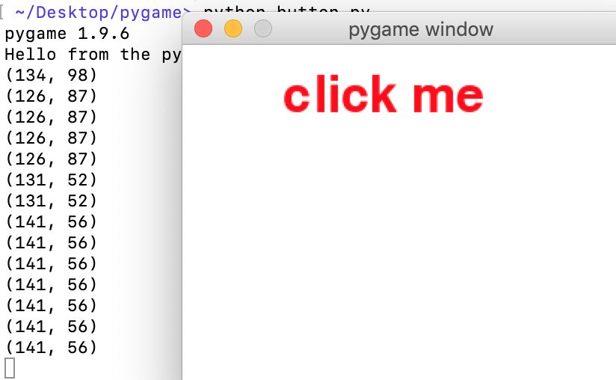

Display the process of animating two images:

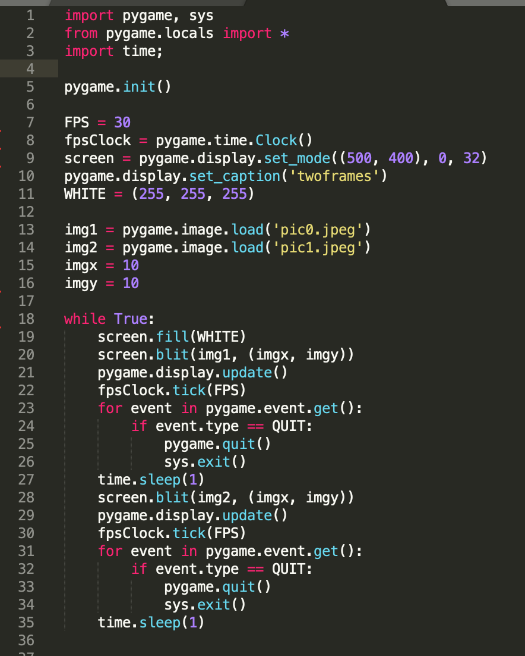

Diagram:

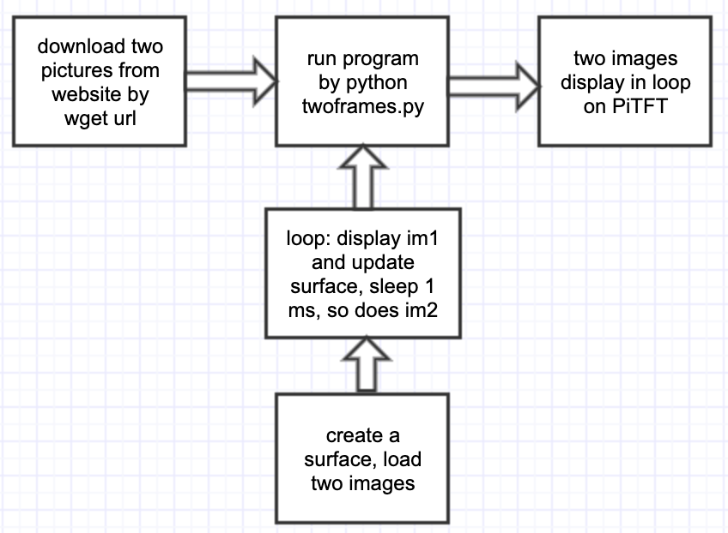

1. 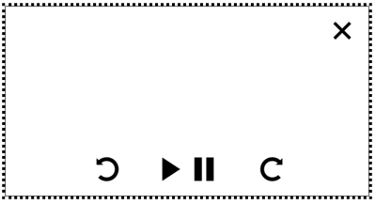

A simple GUI could look like this, comprised of a play button, a pause button, a forward button, a rewind button at the bottom and a quit button on the up right corner of TFT.

Control logic of GUI is shown below.

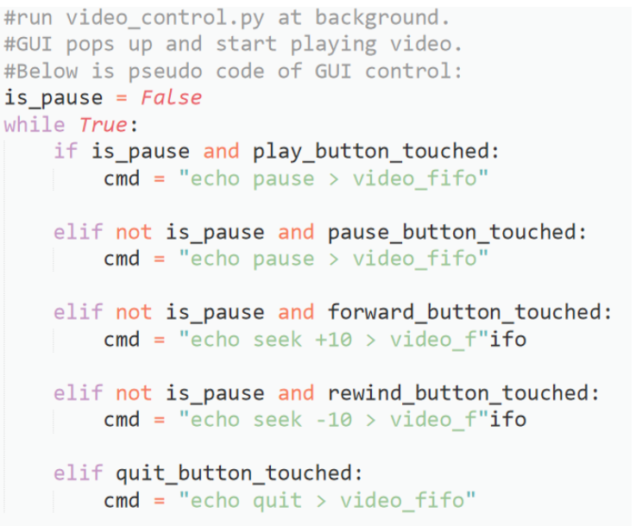

1. If we don’t first create video_fifo, when we press a button, vidoe_control.py cannot find the fifo file, so don’t know where to send command. The mplayer will not change anything but continuously play the video. This way will not create a fifo file, and mplayer will not be controlled correctly. If video_fifo is created correctly, mplayer will receive commands from fifo file and respond correctly.